**PROGRAM-1**

**Write a program to develop a static website using HTML tables.**

**Program:**

***index.html***

<!DOCTYPE html>

<html>

<head>

    <title>Home</title>

</head>

<body>

<center>

    <img src="mj_logo.jpg" width="500">

</center>

<br><br>

<center>

<table border="1" width="70%" cellpadding="10" cellspacing="5">

    <tr align="center">

        <td><a href="index.html">Home</a></td>

        <td><a href="about.html">About</a></td>

        <td><a href="vision.html">Vision</a></td>

        <td><a href="mission.html">Mission</a></td>

        <td><a href="register.html">Register</a></td>

    </tr>

</table>

</center>

<br><br>

<center>

    <img src="cse.jpg" width="700">

    <h1>CSE Department</h1>

    <p>Welcome to the Computer Science And Engineering Department.</p>

    <br>

    <p>Designed by 1604-22-733-121</p>

</center>

</body>

</html>

----------------

***about.html***

<!DOCTYPE html>

<html>

<head>

    <title>About</title>

</head>

<body>

<center><h1>About Us</h1></center>

<center>

<table border="1" width="70%" cellpadding="10" cellspacing="5">

    <tr align="center">

        <td><a href="index.html">Home</a></td>

        <td><a href="about.html">About</a></td>

        <td><a href="vision.html">Vision</a></td>

        <td><a href="mission.html">Mission</a></td>

        <td><a href="register.html">Register</a></td>

    </tr>

</table>

</center>

<br><br>

<center>

    <img src="about.png" width="400">

    <p>Established in 1980, Muffakham Jah College of Engineering and Technology is a premier institute of its kind, offering four year B.E. degree courses in 7 Engineering branches, namely, Civil Engineering, Computer Science Engineering, Computer Science Engineering (Artificial Intelligence), Computer Science Engineering (Artificial Intelligence & Machine Learning), Computer Science Engineering (Data Science), Electronics and Communication Engineering, Mechanical Engineering and four post graduate courses in M.E. (CAD/CAM), M.E. (Structural Engineering), M.E. (Embedded Systems & VLSI Design), M. Tech. (Computer Science) of two years duration. The College is a Minority Autonomous Educational Insitution affiliated to Osmania University and is approved by the AICTE and accredited by the NAAC with Grade A+ and four UG programs Civil Engineering, Computer Science and Engineering, Electronics and Communication Engineering and Mechanical Engineering are accredited by NBA for a period of 3 years from 2024-25 to 2026-27 up to 30-6-2027.</p>

</center>

</body>

</html>

----------------------------

***vision.html***

<!DOCTYPE html>

<html>

<head>

    <title>Vision</title>

</head>

<body>

<center><h1>Vision</h1></center>

<center>

<table border="1" width="70%" cellpadding="10" cellspacing="5">

    <tr align="center">

        <td><a href="index.html">Home</a></td>

        <td><a href="about.html">About</a></td>

        <td><a href="vision.html">Vision</a></td>

        <td><a href="mission.html">Mission</a></td>

        <td><a href="register.html">Register</a></td>

    </tr>

</table>

</center>

<br><br>

<center>

    <img src="vm.png" width="500">

    <p>To empower the faculty and students in the area of Research & Development by providing seed funds for implementing their innovative research and product development ideas.</p>

</center>

</body>

</html>

----------------------------

***mission.html***

<!DOCTYPE html>

<html>

<head>

    <title>Mission</title>

</head>

<body>

<center><h1>Mission</h1></center>

<center>

<table border="1" width="70%" cellpadding="10" cellspacing="5">

    <tr align="center">

        <td><a href="index.html">Home</a></td>

        <td><a href="about.html">About</a></td>

        <td><a href="vision.html">Vision</a></td>

        <td><a href="mission.html">Mission</a></td>

        <td><a href="register.html">Register</a></td>

    </tr>

</table>

</center>

<br><br>

<center>

    <img src="vm.png" width="500">

            <p>

                To motivate faculty and students to undertake Research and Development activities

                as a means of nourishing innovative thought process.

            </p>

            <p>

                To encourage interdisciplinary Research and Development projects leading to

                solutions for real world problems through the synthesis of diverse ideas and skills.

            </p>

            <p>

                To serve as a medium for three-way interaction between the Institute,

                Research and Development organizations, and Industry.

            </p>

            <p>

                To assist faculty, Ph.D. scholars, and students to apply for funding under

                various Government, Professional Chapter, or Private Sector schemes.

            </p>

            <p>

                To encourage publication of technical papers in National and International

                refereed journals and conferences based on research carried out by faculty

                and students.

            </p>

            <p>

                To register outcomes of Research and Development work under Intellectual

                Property Rights such as patents and copyrights.

            </p>

            <p>

                To facilitate signing of Memorandum of Understanding (MoU) with industries

                and Research and Development organizations for research and product development.

            </p>

</center>

</body>

</html>

----------------------

***register.html***

<!DOCTYPE html>

<html>

<head>

    <title>Registration</title>

</head>

<body>

<center><h1>Student Registration</h1></center>

<center>

<table border="1" width="70%" cellpadding="10" cellspacing="5">

    <tr align="center">

        <td><a href="index.html">Home</a></td>

        <td><a href="about.html">About</a></td>

        <td><a href="vision.html">Vision</a></td>

        <td><a href="mission.html">Mission</a></td>

        <td><a href="register.html">Register</a></td>

    </tr>

</table>

</center>

<br><br>   <!-- GAP HERE -->

<center>

<form>

    Name: <input type="text"><br><br>

    Email: <input type="text"><br><br>

    <input type="submit" value="Submit">

</form>

</center>

</body>

</html>

**Output:**

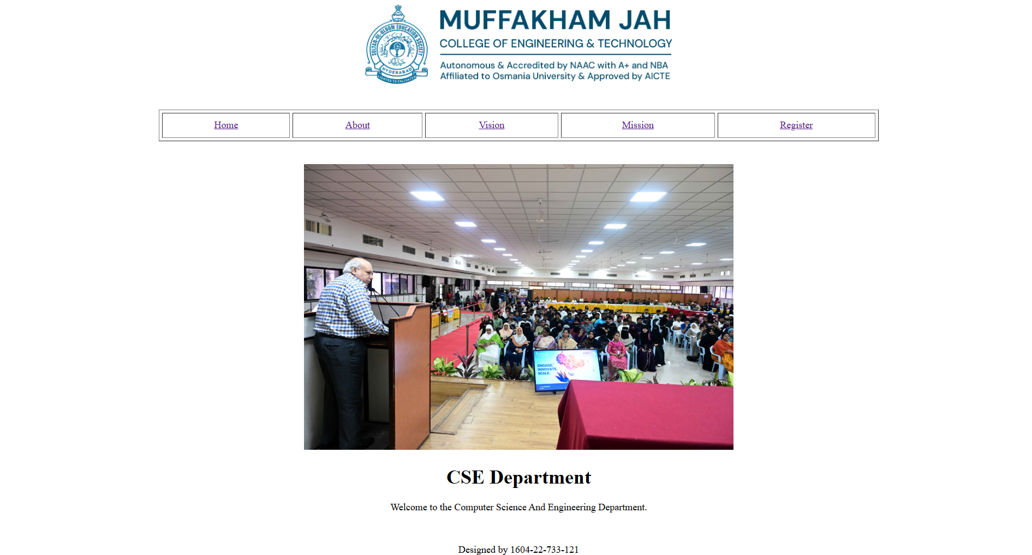

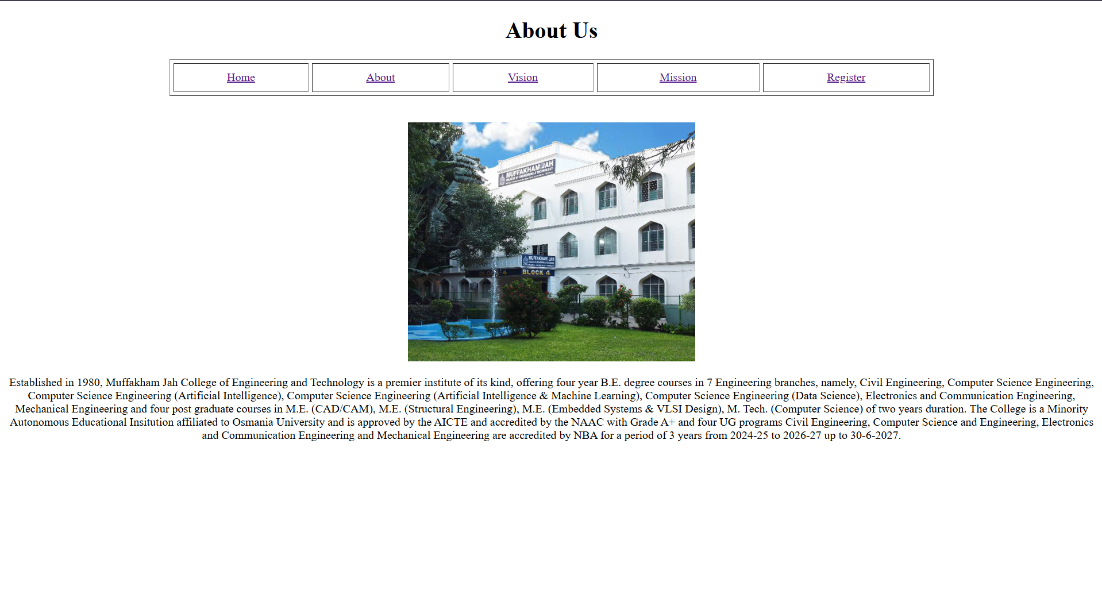

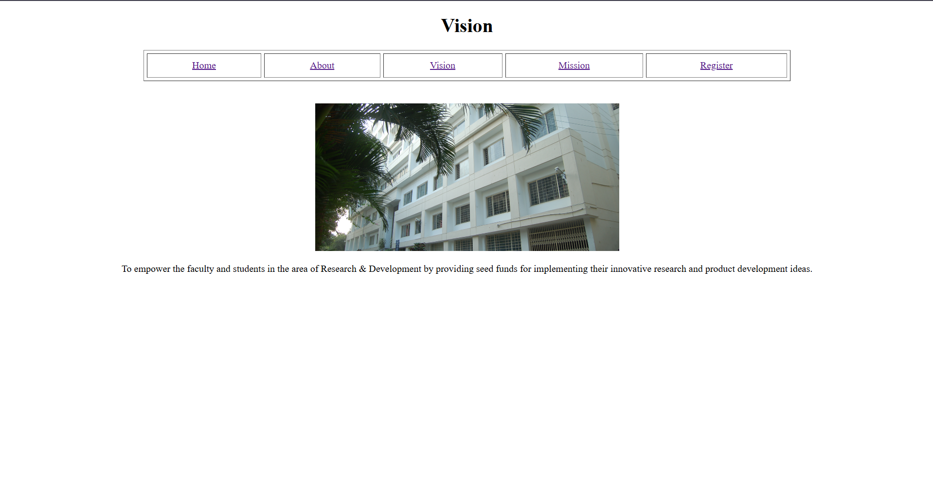

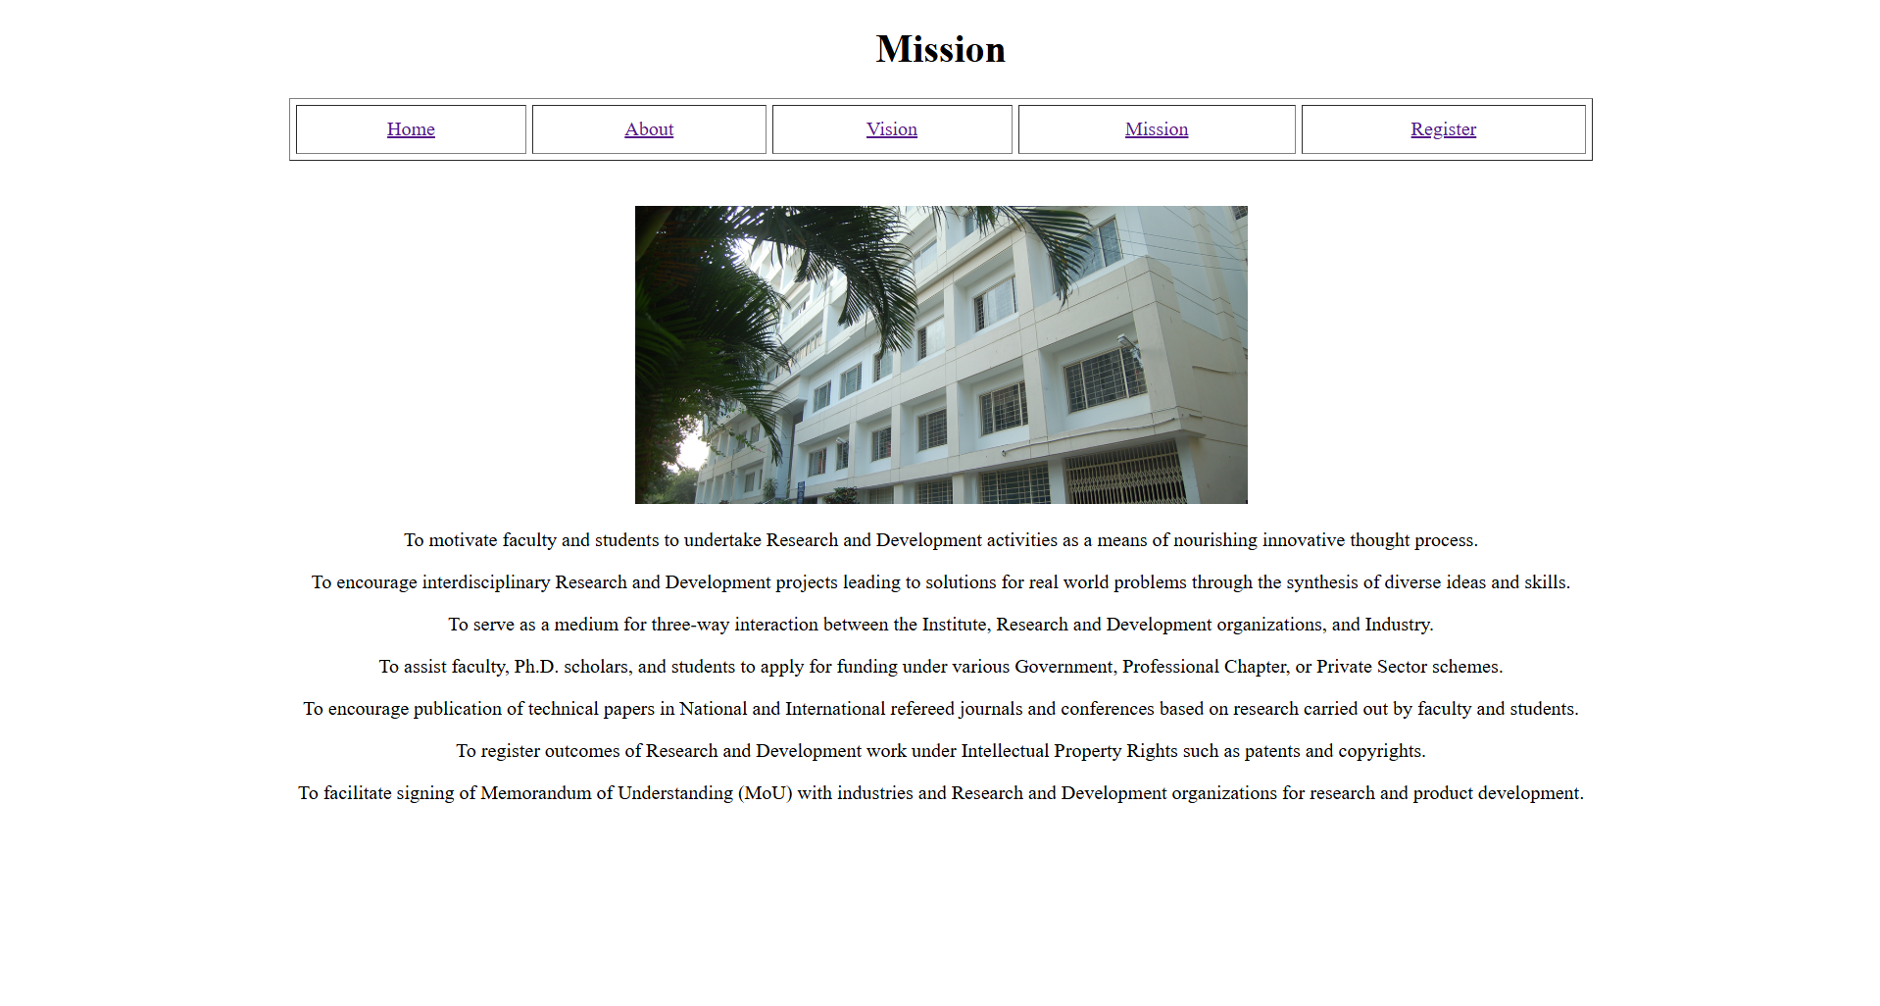

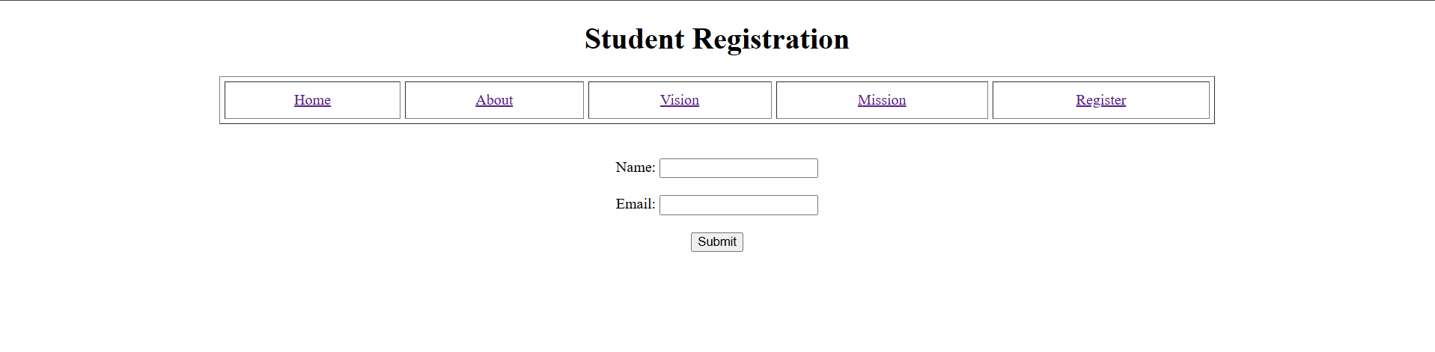

**Program-2**

**Develop a static website using DIV and CSS**

***Index.html***

<!DOCTYPE html>

<html>

<head>

    <title>Home Page</title>

    <!-- External CSS -->

    <link rel="stylesheet" href="style.css">

    <!-- Internal CSS -->

    <style>

        #mainTitle {

            color: darkblue;

            text-decoration: underline;

        }

    </style>

</head>

<body>

<div class="content">

    <img src="mj_logo.jpg" width="450">

</div>

<br>

<div class="nav">

    <div><a href="index.html">Home</a></div>

    <div><a href="about.html">About</a></div>

    <div><a href="vision.html">Vision</a></div>

    <div><a href="mission.html">Mission</a></div>

    <div><a href="register.html">Register</a></div>

</div>

<br>

<div class="content">

    <img src="cse.jpg" width="650">

    <h1 id="mainTitle">Computer Science Engineering</h1>

    <p style="color: darkgreen;">

        Welcome to the Computer Science Engineering Department.

    </p>

    <p>

        Designed by <b>1604-22-733-121</b>

    </p>

</div>

</body>

</html>

-----------

***style.css***

body {

    font-family: Arial, sans-serif;

    background-color: #f5f5f5;

}

.nav {

    width: 75%;

    margin: auto;

    border: 2px solid black;

    text-align: center;

    background-color: #e6e6e6;

}

.nav div {

    display: inline-block;

    padding: 12px;

}

.content {

    text-align: center;

    margin-top: 25px;

}

**Output:**

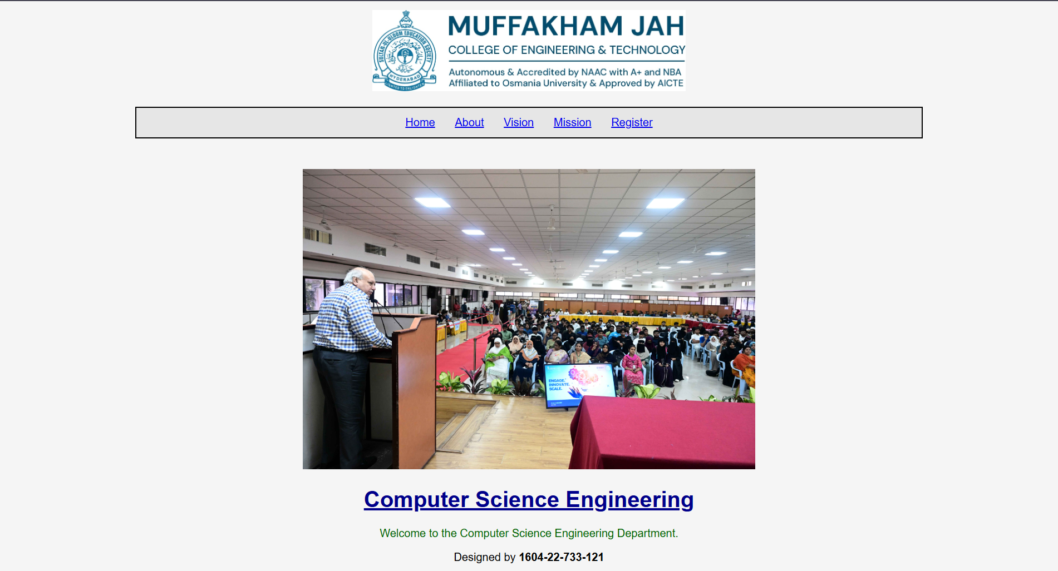

**Program-3**

**Develop a registration page using HTML forms**

***Index.html***

<!DOCTYPE html>

<html>

<head>

    <!-- Title of the webpage -->

    <title>Registration Form</title>

    <!-- Linking external CSS file -->

    <link rel="stylesheet" href="form.css">

</head>

<body>

<!-- Main container to center the form -->

<div class="container">

    <!-- Form heading -->

    <h2>Student Registration Form</h2>

    <!-- Form starts here -->

    <form>

        <!-- TEXT FIELD: Name -->

        <label>Name</label>

        <input type="text" placeholder="Enter your name">

        <!-- PASSWORD FIELD -->

        <label>Password</label>

        <input type="password" placeholder="Enter password">

        <!-- DROPDOWN LIST -->

        <label>Branch</label>

        <select>

            <option>Select Branch</option>

            <option>CSE</option>

            <option>ECE</option>

            <option>MECH</option>

            <option>CIVIL</option>

        </select>

        <!-- LIST BOX (Multiple selection using Ctrl key) -->

        <label>Subjects (Hold Ctrl to select multiple)</label>

        <select multiple size="4">

            <option>DSA</option>

            <option>DBMS</option>

            <option>OS</option>

            <option>AI</option>

        </select>

        <!-- RADIO BUTTONS (Select only one) -->

        <label>Gender</label>

        <div class="options">

            <input type="radio" name="gender"> Male

            <input type="radio" name="gender"> Female

        </div>

        <!-- CHECKBOXES (Select one or more) -->

        <label>Skills</label>

        <div class="options">

            <input type="checkbox"> Python

            <input type="checkbox"> Java

            <input type="checkbox"> C

        </div>

        <!-- TEXT AREA -->

        <label>Address</label>

        <textarea rows="4"></textarea>

        <!-- SUBMIT & RESET BUTTONS (Inline CSS used here) -->

        <div class="buttons">

            <input type="submit" value="Submit"

                   style="background-color: navy; color: white;">

            <input type="reset" value="Reset"

                   style="background-color: gray; color: white;">

        </div>

    </form>

    <!-- Form ends here -->

</div>

<!-- Container ends here -->

</body>

</html>

------------

***form.css***

/* Style applied to entire page */

body {

    font-family: Arial, sans-serif;

    background-color: #f0f2f5;

}

/* Container div to center the form */

.container {

    width: 450px;

    background-color: white;

    padding: 20px;

    margin: 50px auto;

    border-radius: 8px;

    box-shadow: 0 0 10px gray;

    box-sizing: border-box;

}

/* Heading style */

h2 {

    text-align: center;

    color: navy;

}

/* Label styling */

label {

    font-weight: bold;

    display: block;

    margin-top: 10px;

}

/* Common style for inputs, dropdowns, textarea */

input, select, textarea {

    width: 100%;

    padding: 8px;

    margin-top: 5px;

    box-sizing: border-box;

}

/* Radio & checkbox input size correction */

.options input {

    width: auto;

    margin-right: 5px;

}

/* Space above option groups */

.options {

    margin-top: 5px;

}

/* Button container */

.buttons {

    text-align: center;

    margin-top: 15px;

}

/* Button styling */

.buttons input {

    padding: 8px 20px;

    margin: 5px;

    border: none;

    cursor: pointer;

}

**Output:**

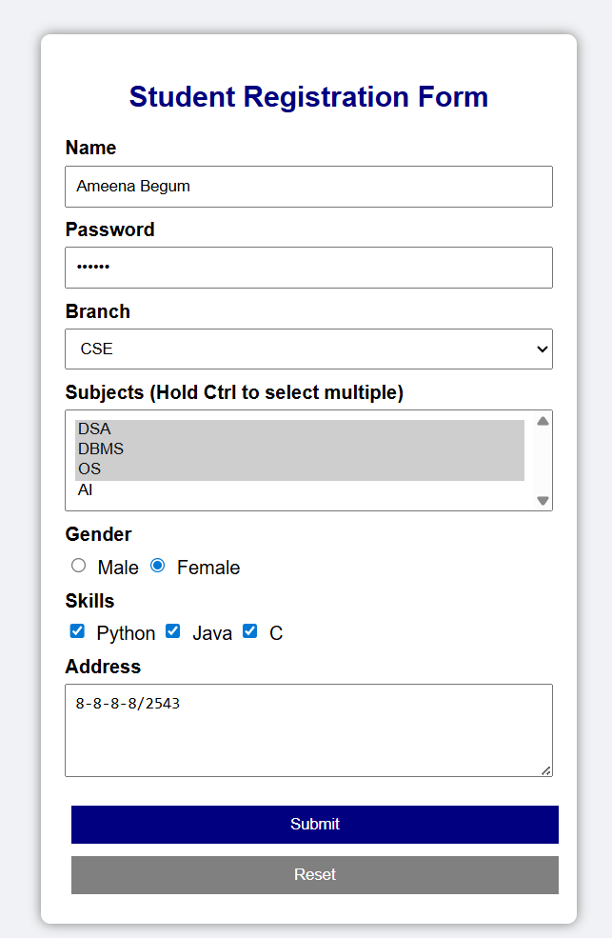

**Program-4**

**Develop a dynamic web page using JavaScript**

<!DOCTYPE html>

<html>

<head>

    <title>Dynamic Web Page</title>

</head>

<body>

<center>

    <h2 id="greeting"></h2>

    <p id="date"></p>

    <h3>Your Lucky Number</h3>

    <p id="lucky"></p>

    <p id="modified"></p>

    <p> Modified by: 1604-22-733-121</p>

</center>

<script>

    // Date object

    var today = new Date();

    var hour = today.getHours();

    // Greeting based on time

    var greet;

    if (hour < 12) {

        greet = "Good Morning";

    } else if (hour < 18) {

        greet = "Good Afternoon";

    } else {

        greet = "Good Evening";

    }

    // Display greeting and date

    document.getElementById("greeting").innerHTML = greet;

    document.getElementById("date").innerHTML = "Today's Date: " + today.toDateString();

    // Math object - random lucky number

    var luckyNumber = Math.floor(Math.random() * 100) + 1;

    document.getElementById("lucky").innerHTML = luckyNumber;

    // Last modified information

    document.getElementById("modified").innerHTML =

        "Last Modified: " + document.lastModified;

</script>

</body>

</html>

**Output:**

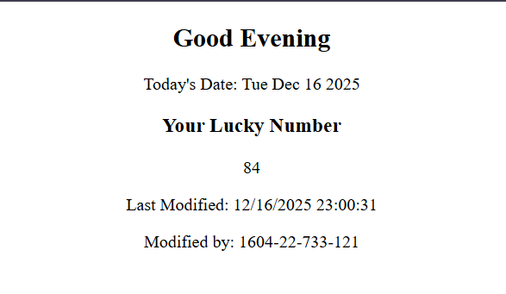

**Program-5**

**Write a JavaScript program to validate the registration**

<html>

<head>

    <title>Registration Form Validation</title>

    <script>

        function validate() {

            /* Roll Number validation */

            var rn = document.getElementById("roll");

            if (rn.value == "") {

                alert("Roll Number cannot be empty");

                return false;

            }

            if (rn.value.search(/[0-9]{4}-[0-9]{2}-[0-9]{3}-[0-9]{3}$/) == -1) {

                alert("Invalid Roll Number");

                return false;

            }

            /* Name validation */

            var sn = document.getElementById("sname");

            if (sn.value == "") {

                alert("Name cannot be empty");

                return false;

            }

            if (sn.value.search(/[A-Z a-z]*$/) == -1) {

                alert("Invalid Name");

                return false;

            }

            /* Password match validation */

            var pass = document.getElementById("pwd");

            var cpass = document.getElementById("cpwd");

            if (pass.value == "" || cpass.value == "") {

                alert("Password fields cannot be empty");

                return false;

            }

            if (pass.value != cpass.value) {

                alert("Passwords do not match");

                return false;

            }

            /* Phone number validation */

            var pho = document.getElementById("ph");

            if (pho.value == "") {

                alert("Phone number cannot be empty");

                return false;

            }

            if (pho.value.search(/[0-9]{10}$/) == -1) {

                alert("Invalid Phone Number");

                return false;

            }

            /* Email validation */

            var em = document.getElementById("email");

            if (em.value.search(/[A-Z a-z 0-9._]*@[A-Z a-z]*\.[A-Z a-z]*$/) == -1) {

                alert("Invalid Email Address");

                return false;

            }

            return true;

        }

    </script>

</head>

<body>

    <h1>Student Registration Form</h1>

    <form onsubmit="return validate();">

        <table border="1">

            <tr><td>Roll No</td><td><input type="text" id="roll"></td></tr>

            <tr><td>Name</td><td><input type="text" id="sname"></td></tr>

            <tr><td>Password</td><td><input type="password" id="pwd"></td></tr>

            <tr><td>Confirm Password</td><td><input type="password" id="cpwd"></td></tr>

            <tr><td>Phone</td><td><input type="text" id="ph"></td></tr>

            <tr><td>Email</td><td><input type="text" id="email"></td></tr>

            <tr><td>Address</td><td><textarea id="addr"></textarea></td></tr>

            <tr>

                <td></td>

                <td>

                    <input type="submit">

                    <input type="reset">

                </td>

            </tr>

        </table>

    </form>

</body>

</html>

**Output:**

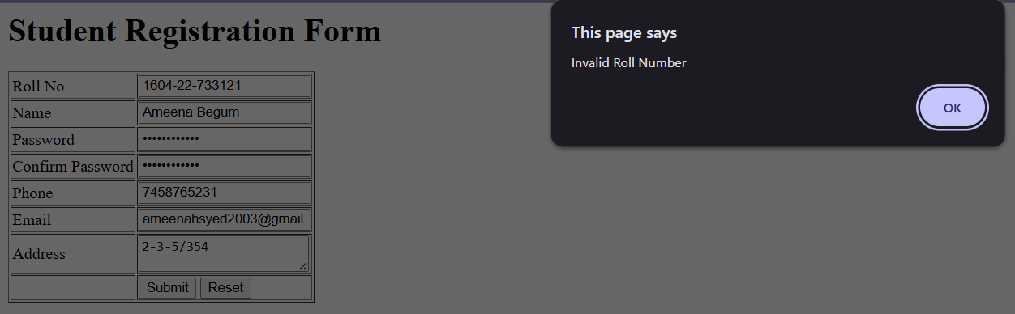

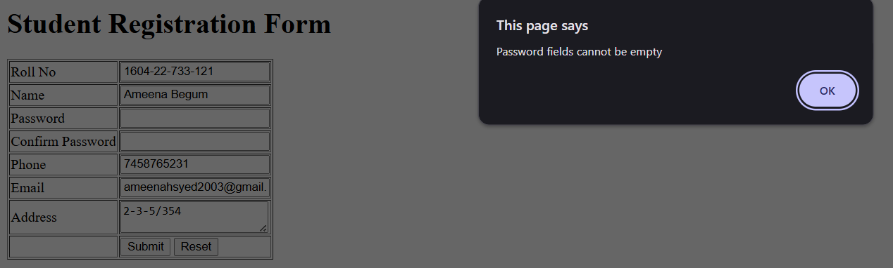

**Program-6**

**Create a dynamic web page using JavaScript event handling and DOM manipulation.**

<!DOCTYPE html>

<html>

<head>

    <title>JavaScript Event Handling</title>

    <script>

        function showInstructions() {

            alert("Read the instructions carefully");

        }

        function validateForm() {

            alert("Form submitted successfully");

        }

        function clearForm() {

            alert("Form cleared");

        }

        /* onclick event + DOM manipulation */

        function copyAddress() {

            var contact = document.getElementById("cta").value;

            document.getElementById("pta").value = contact;

        }

        function focusPhone() {

            document.getElementById("phone").style.color = "red";

        }

        function blurPhone() {

            document.getElementById("phone").style.color = "black";

        }

    </script>

</head>

<body onload="showInstructions()">

<center>

    <h1>JavaScript Event Handling Demo</h1>

    <form onsubmit="validateForm()" onreset="clearForm()">

        Name:

        <input type="text" id="sname" onblur="alert('Name field left')">

        <br><br>

        Phone No:

        <input type="text" id="phone"

               onfocus="focusPhone()"

               onblur="blurPhone()">

        <br><br>

        Contact Address:

        <textarea id="cta"></textarea>

        <br><br>

        Permanent Address:

        <textarea id="pta"></textarea>

        <br><br>

        <input type="button"

               value="Same as Contact Address"

               onclick="copyAddress()">

        <br><br>

        <!-- Mouseover & Mouseout demo -->

        <p id="hoverText">Move mouse over this text</p>

        <input type="submit" value="Submit">

        <input type="reset" value="Reset">

        <br><br>

        <input type="button" value="Button-3" id="btn3">

    </form>

</center>

<!-- DOM handling using addEventListener -->

<script>

    /* mouseover & mouseout using DOM */

    var txt = document.getElementById("hoverText");

    txt.onmouseover = function () {

        txt.style.color = "blue";

        alert("Mouse Over Event");

    };

    txt.onmouseout = function () {

        txt.style.color = "black";

        alert("Mouse Out Event");

    };

    /* click event using addEventListener */

    var btn = document.getElementById("btn3");

    btn.addEventListener("click", function () {

        alert("Button-3 Clicked Listener 1");

    });

    btn.addEventListener("click", function () {

        alert("Button-3 Clicked Listener 2");

    });

</script>

</body>

</html>

**Output:**

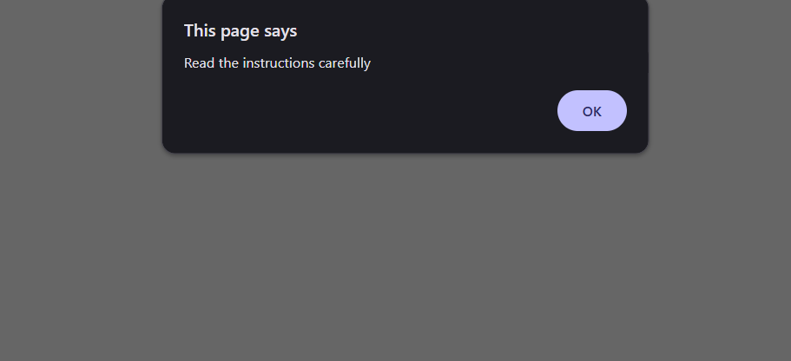

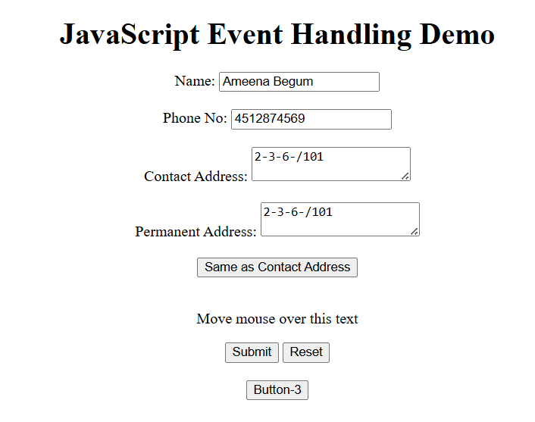

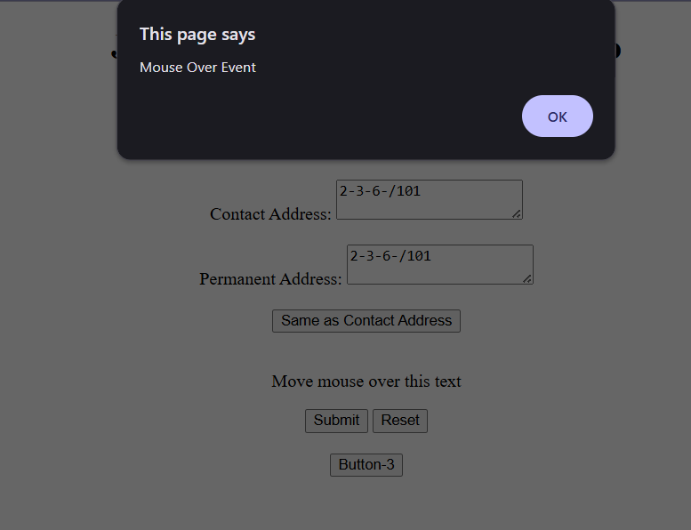

**Program-7**

**Demonstrate working of built-in node.js modules and file system.**

***index.js***

var http = require('http');

var os = require('os');

var fs = require('fs');

// HTTP Server

var server = http.createServer(function (req, res) {

    res.writeHead(200, { 'Content-Type': 'text/html' });

    res.write('Hello Web Technologies Lab <br>');

    res.write('Date: ' + Date() + '<br>');

    res.write('Platform: ' + os.platform() + '<br>');

    res.write('Architecture: ' + os.arch() + '<br>');

    res.write('Host Name: ' + os.hostname() + '<br>');

    res.write('OS Type: ' + os.type() + '<br>');

    var text = fs.readFileSync('content.txt', 'utf8');

    res.write('<br>File Content:<br>' + text);

    res.end();

});

server.listen(8080);

// File System Operations

fs.open('myfile1.txt', 'w', function (err, file) {

    if (err) throw err;

    console.log('File opened');

});

fs.writeFile('myfile3.txt', 'hello lab', function (err) {

    if (err) throw err;

    console.log('File written');

});

fs.appendFile('myfile1.txt', ' hello web', function (err) {

    if (err) throw err;

    console.log('File appended');

});

fs.rename('myfile3.txt', 'myfile4.txt', function (err) {

    if (err) throw err;

    console.log('File renamed');

});

**Output:**

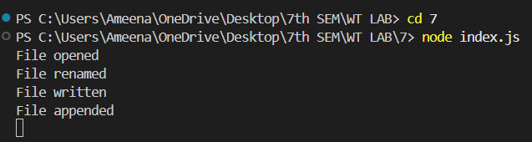

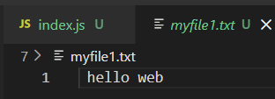

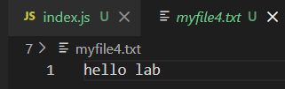

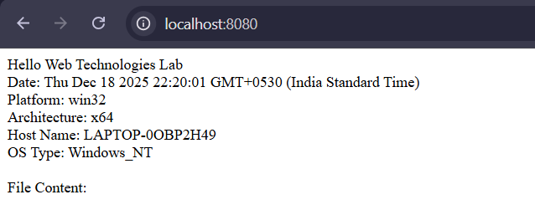

**Program-8**

**Demonstrate routes and parameter handling in Express.js**

***login.js***

var express=require('express');

var router=express.Router();

router.get('/',(req,res)=>{

res.send('Login Page');

});

router.post('/',(req,res)=>{

res.send('Login Page');

});

module.exports=router;

-------------

***signup.js***

var express=require('express');

var router=express.Router();

router.get('/',(req,res)=>{

res.send('Sign Up Page');

});

router.post('/',(req,res)=>{

res.send('Signup page');

});

module.exports=router;

--------------

***index.js***

var express=require('express')

var app=express();

var loginroute=require('./Routes/login');

var signuproute=require('./Routes/signup');

app.get('/',(req,res)=>{

res.send('Hello Lab');

});

app.use('/login',loginroute);

app.use('/signup',signuproute);

app.get('/display/:uname/:pwd',(req,res)=>{

var values=req.params;

console.log(values);

console.log(req.query);

res.send('Values Received :'+req.params.uname);

});

app.listen(8080);

**Output**

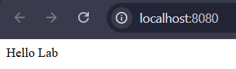

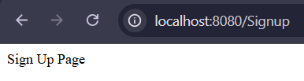

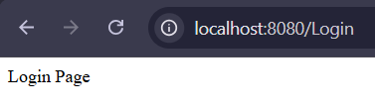

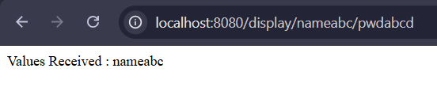

**PROGRAM-9**

**Write a program to implement the MVC Architecture**

***Memo.ejs***

<html>

<head>

<title>

Marks Memo

</title>

</head>

<body>

<center>

<h1>Marks Memo</h1>

<h2> 1604-22-733-121</h2>

<table width="60%" border="1">

<tr>

<th>S.No</th>

<th>Code</th>

<th>Subject</th>

<th>Internal Marks</th>

<th>External Marks</th>

</tr>

<% data.forEach(function(data){ %>

<tr align="center">

<td><%= data.id %></td>

<td><%= data.code %></td>

<td align="left"><%= data.sub %></td>

<td><%= data.imarks %></td>

<td><%= data.emarks %></td>

</tr>

<% }) %>

</table>

</center>

</body>

</html>

-----------------

***index.js***

var express = require("express");

var app = express();

app.set("view engine", "ejs");

app.set("views", __dirname + "/views");

var data = [

  { id: 1, code: "CS401", sub: "DAA", imarks: 28, emarks: "S" },

  { id: 2, code: "CS402", sub: "CN", imarks: 30, emarks: "A" },

  { id: 3, code: "CS403", sub: "OS", imarks: 22, emarks: "B" },

  { id: 4, code: "CS404", sub: "Java", imarks: 25, emarks: "C" }

];

app.get("/", (req, res) => {

  res.render("memo", { data });

});

app.listen(8080, () => {

  console.log("Server running on port 8080");

});

**Output:**

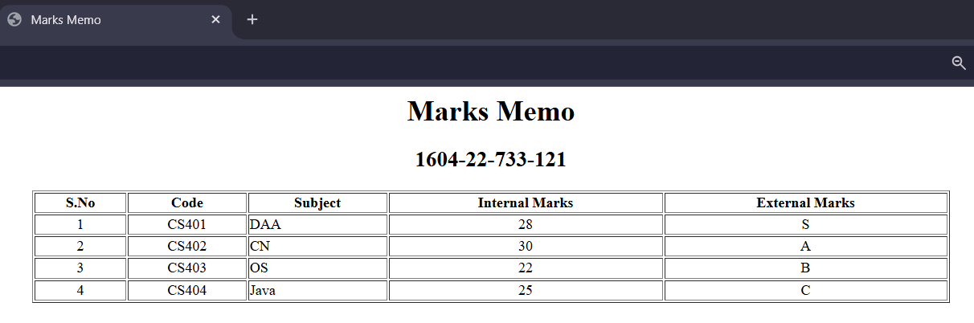

**PROGRAM 10**

**Demonstrate rendering HTML and JSX using React.js**

import './App.css';

function App() {

  const collegeName = "Muffakham Jah College";

  const links = (

    <div>

      <a href="#">Faculty</a><br />

      <a href="#">Staff</a><br />

      <a href="#">Students</a><br />

    </div>

  );

  const today = new Date();

  return (

    <div className="App">

      <h1>{collegeName}</h1>

      <h2 style={{ color: "blue" }}>CSE Department</h2>

      {links}

      <p>{today.toDateString()}</p>

      <h3>Mission</h3>

      <p>

        To mentor students towards a successful professional career in a

        global environment through quality education.

      </p>

      <p style={{ fontStyle: "italic", marginTop: "20px" }}>

        Designed by: 1604-22-733-121

      </p>

    </div>

  );

}

export default App;

**Output:**

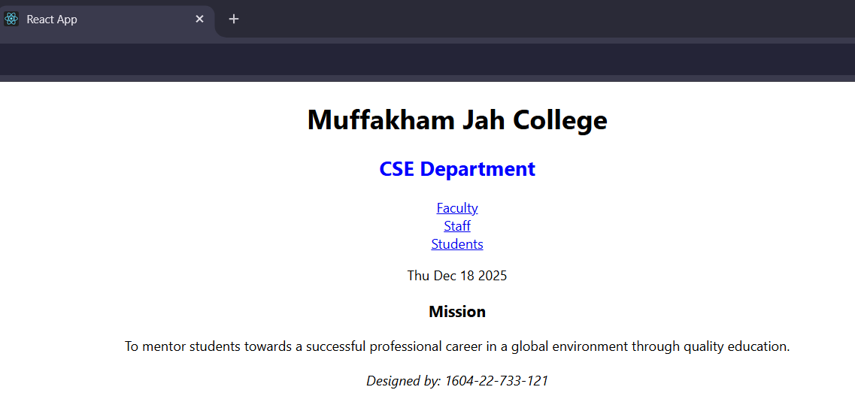

**PROGRAM 11**

**Demonstrate use of props, events, lists, forms using React.js**

import logo from './logo.svg';

import './App.css';

function App() {

return (

<div className="App">

<GetUser name="ABC" uid={100} />

<GetUser name="XYZ" uid={101} />

<MyForm />

<StudentsData />

<EventDemo />

</div>

);

}

function GetUser(props) {

return(

<div>

<p>{props.name}</p>

<p>{props.uid}</p>

</div> )

}

function MyForm() {

return (

<form>

Name: <input type='text'></input><br></br>

Email: <input type='text'></input><br></br>

Password: <input type='text'></input><br></br>

<input type='Submit'></input><br></br>

<input type='Reset'></input><br></br>

</form>

)

}

function StudentsData()

{

var list=[

{roll:1,name:'AAA'},

{roll:2,name:'BBB'},

{roll:3,name:'CCC'},

{roll:4,name:'DDD'}

];

return(

<>

<h1>Students List</h1>

<ul>

{list.map((row) => <li key={row.roll}>{row.name}</li>)}

</ul>

</>

)

}

function EventDemo()

{

var display=() =>{

alert('Hello');

}

return(

<button onClick={display}>Click Here</button>

);

}

export default App;

**Output:**

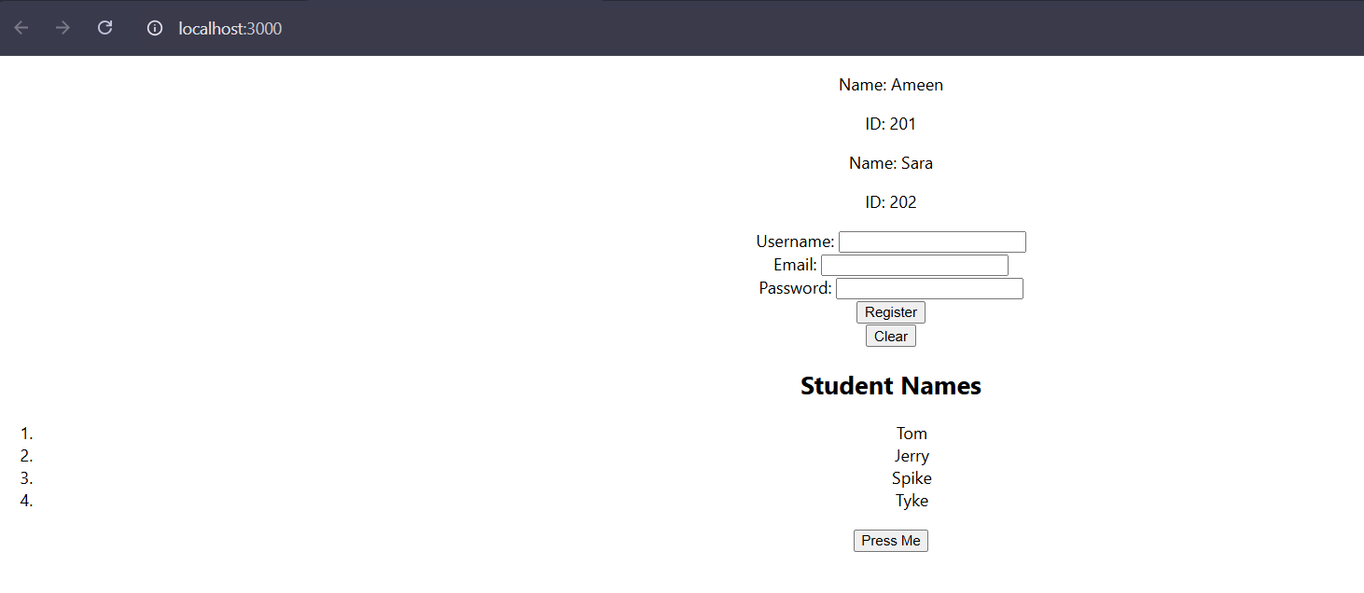

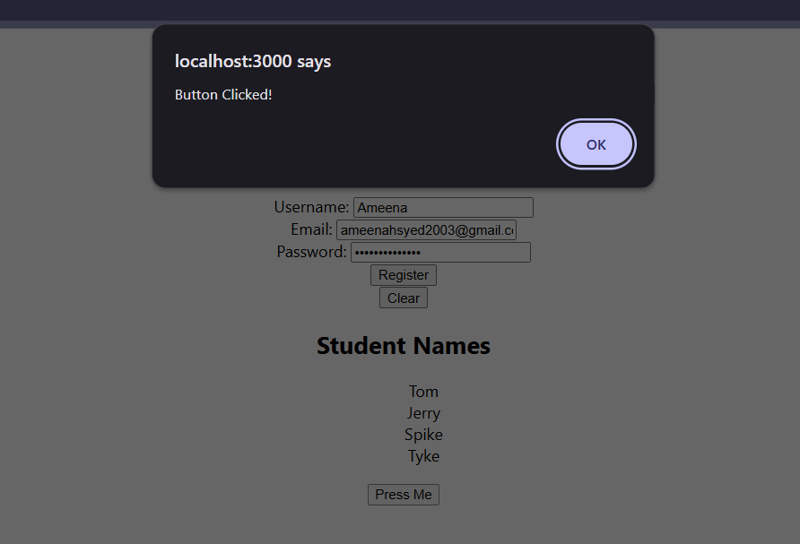

**PROGRAM-12**

**Create a Single Page Application (SPA) using REST service.**

***RestServices/Index.js***

var express = require('express');

var cors = require('cors');

var fs = require("fs");

var app = express();

app.use(cors());

app.get('/students', function(req, res) {

  fs.readFile(__dirname + "/students.json", 'utf8', function(err, data) {

    res.end(data);

  });

});

app.get('/imarks', function(req, res) {

  fs.readFile(__dirname + "/imarks.json", 'utf8', function(err, data) {

    res.end(data);

  });

});

app.get('/emarks', function(req, res) {

  fs.readFile(__dirname + "/emarks.json", 'utf8', function(err, data) {

    res.end(data);

  });

});

app.listen(5000, () => {

  console.log("REST Service running on port 8080");

});

**JSON -----**

***emarks.json***

[

  { "id": 2001, "marks": 85 },

  { "id": 2002, "marks": 78 },

  { "id": 2003, "marks": 90 },

  { "id": 2004, "marks": 88 },

  { "id": 2005, "marks": 92 }

]

***imarks.json***

[

  { "id": 2001, "marks": 28 },

  { "id": 2002, "marks": 26 },

  { "id": 2003, "marks": 30 },

  { "id": 2004, "marks": 27 },

  { "id": 2005, "marks": 29 }

]

***students. Json***

[

  { "id": 2001, "name": "Ayesha" },

  { "id": 2002, "name": "Sara" },

  { "id": 2003, "name": "Rahul" },

  { "id": 2004, "name": "Neha" },

  { "id": 2005, "name": "Kiran" }

]

***Spa/App.js***

import React, { Component } from 'react';

import './App.css';

class App extends Component {

  constructor(props) {

    super(props);

    this.state = {

      studentData: [],

      internalMarks: [],

      externalMarks: []

    };

  }

  componentDidMount() {

    this.loadStudents();

  }

  loadStudents() {

    fetch("http://localhost:8080/students")

      .then(res => res.json())

      .then(result => {

        this.setState({ studentData: result });

      });

  }

  showInternalMarks() {

    fetch("http://localhost:8080/imarks")

      .then(res => res.json())

      .then(result => {

        this.setState({ internalMarks: result });

      });

  }

  showExternalMarks() {

    fetch("http://localhost:8080/emarks")

      .then(res => res.json())

      .then(result => {

        this.setState({ externalMarks: result });

      });

  }

  render() {

    const { studentData, internalMarks, externalMarks } = this.state;

    return (

      <div className="App">

        <h1>Student Marks Information</h1>

        <button onClick={() => this.showInternalMarks()}>

          Show Internal Marks

        </button>

        <button onClick={() => this.showExternalMarks()}>

          Show External Marks

        </button>

        <table border="1" align="center">

          <tr>

            <th>Student Name</th>

            <th>Internal</th>

            <th>External</th>

          </tr>

          <tr>

            <td>

              {studentData.map(s => (

                <div key={s.id}>{s.name}</div>

              ))}

            </td>

            <td>

              {internalMarks.map(i => (

                <div key={i.id}>{i.marks}</div>

              ))}

            </td>

            <td>

              {externalMarks.map(e => (

                <div key={e.id}>{e.marks}</div>

              ))}

            </td>

          </tr>

        </table>

      </div>

    );

  }

}

export default App;

**Output:**

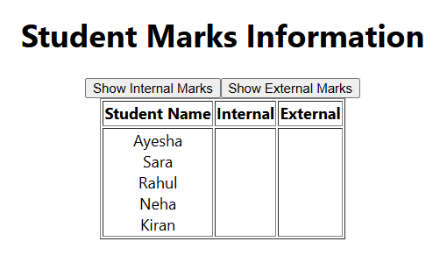

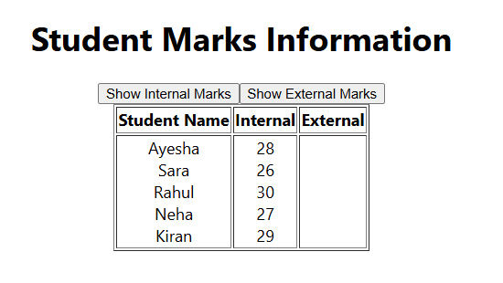

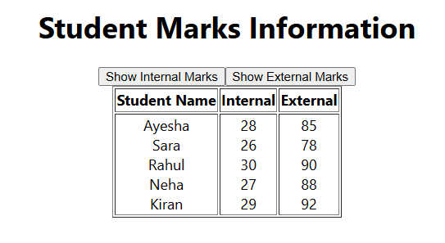

**PROGRAM-13**

**Write a Node.js program to create DB and Collections in MongoDB**

***index.js***

var MongoClient=require('mongodb').MongoClient;

var url="mongodb://localhost:27017/mymongodb";

MongoClient.connect(url,function(err,db){

if(err) throw WriteError;

console.log("Database created!");

db.close();

});

MongoClient.connect(url,function(err,db){

if(err) throw err;

var dbo=db.db("mymongodb");

dbo.createCollection("students1",function(err,res) {

if(err) throw err;

console.group("Collection created!");

db.close();

});

});

**Output:**

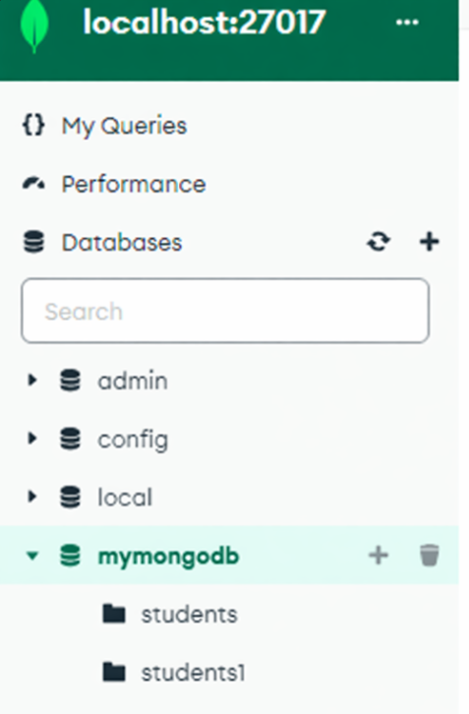

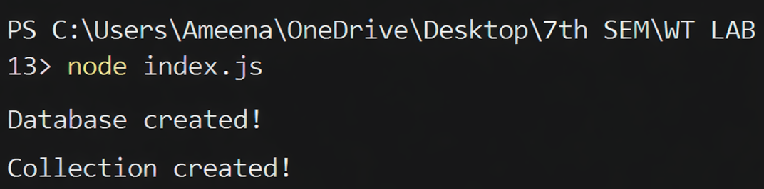

**PROGRAM-14**

**Write a react.js program to retrieve data from MongoDB**

***Restservice index.js***

var express = require('express');

var MongoClient = require('mongodb').MongoClient;

var cors = require('cors');

var app = express();

app.use(cors());

var port = 8080;

var url = 'mongodb://127.0.0.1:27017/mymongodb';

var databasename = 'mymongodb';

var database;

app.get('/retrieve', function (req, res) {

database.collection("students121").find({}).toArray((err, result) => {

if (err) throw err;

console.log(result);

res.send(result);

});

})

app.listen(port, ()=>{

console.log('Mongo Connection Initiated...');

MongoClient.connect(url, function (err, client) {

database = client.db(databasename);

console.log('Mongo Connected');

});

});

**Output:**

